

**Benchmarking Analysis: Indian Cement Industry**

India is the second largest producer of cement globally with a total of 210 large and 350 small plants that produced 455 Million Tonnes of cement in 2017-2018.

Cement industry in India is a vital contributor to the Indian economy and is growing at a rate of 5-6% per annum. Though there are over 106 companies in the cement industry, 77% of the total production is contributed by the top 20 companies, with Ultratech leading the market.

**What is Benchmarking Analysis and Why is it required?**

Benchmarking Analysis is comparing the processes and performances of a company to Industry’s best.

It helps companies in identifying where they can improve and where are they going in terms of performance, financial or operational.

In this report, we have analysed two companies (UltraTech and Shree Cements Ltd.) on their performance from 2014 to 2018.

**\*\*As of 2017-2018:**

|  |  |
| --- | --- |
| **Company** | **Capacity(mT)** |
| Shree | ~25.6 |
| Ultratech | ~98 |

|  |  |
| --- | --- |
| **Company** | No. of Plants |
| Shree | 10 |
| Ultratech | 18 |

|  |  |
| --- | --- |
| **Company** | **Capitalisation** |
| Shree | Rs 109,655.56 Crore |
| Ultratech | Rs 57,399.03 Crore |

**No. of Plants across India Production Capacity Market Capitalisation**

1. **Revenue**:

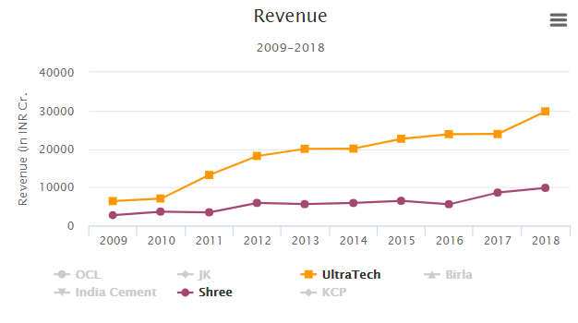Ultratech’s Revenue has gone up from INR 20,077.88 Cr. in 2014 to INR 29,970.1 Cr in 2018 (~49% rise)

Whereas Shree has gone up from INR 5887.31 Cr. in 2014 to INR 9833.1 Cr in 2018 (~67% rise).

In 2009 the revenue generated by both the companies differed by only INR 3672.45 Cr. and in 2018, this difference became INR 19,957 Cr. because of the slow growth of Shree Cement.

1. **Gross Margin and Net Margin**

Ultratech’s Gross Margin has gone up from 83.43% in 2014 to 84.29% in 2018. Whereas, Shree has gone up from 92.4% in 2014 to 92.17% in 2018.

Ultratech showed a gradual fall in the profit margin whereas the net profit margin of Shree Cement fell suddenly various times in 2011, 2014, and 2015.

The Net profit margin of Ultratech has reduced significantly from 11.74% in 2014 to 5.49% in 2018. On the other side, Shree went down from 10.23% to 10.12%.

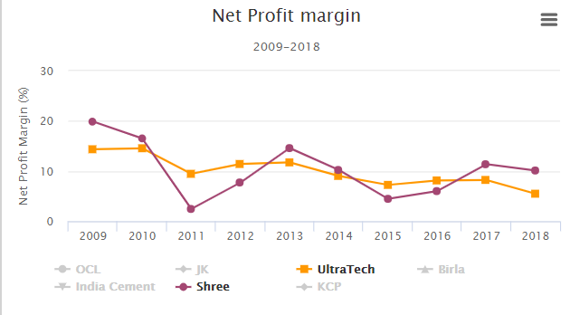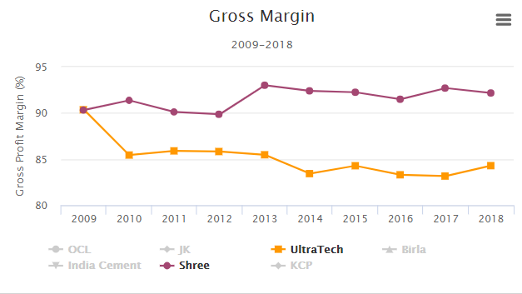

* **Shree’s Revenue has gone up, but Net Profit Margin has decreased. Possible reasons:**

1. Higher expenses.
2. High repair expenses (demonstrate the quality of the cement produced).
3. High employee benefits indicate that the workforce has increased but revenue

generated per employee is significantly lesser than expected.

1. **Change in Share Prices** (closing)**:**

From 2014 to 2018, Shree’s Share price has increased by 77% whereas Ultratech’s Share price has increased by 50.8% only, which is a good sign for Shree.

* + Even though Shree’s Revenue has increased but the fall in Profit Margin and rise in expenses have affected the growth of the company.
    - This gives a scope of improvement in the selling price of Cement and the operating costs of the company.

**“We at dDriven use data-driven approach to help industries in identifying potential factors affecting their growth and provide them with the solution through Operations Digitalization.**

**dDriven unleashes machine, manufacturing and business data to create live digital replicas of the entire enterprise and digitalize every aspect of manufacturing and business operations**.**”**